Model Building

Logistic model evaluation metrics for the latest version
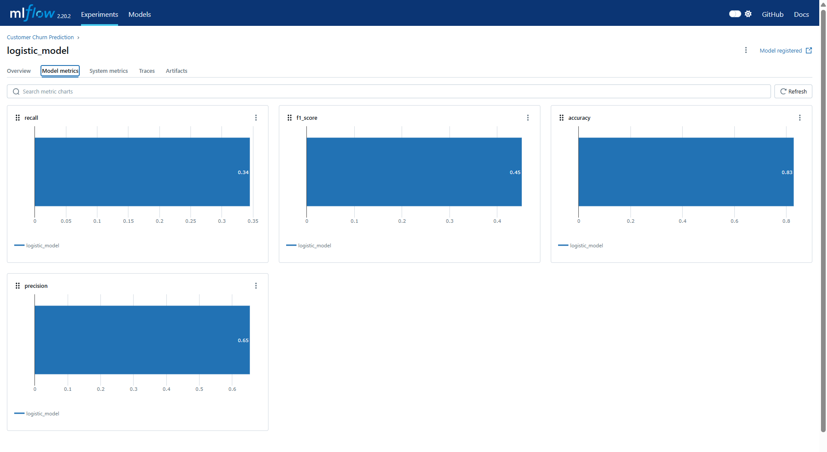

Random forest model evaluation metrics for the latest version
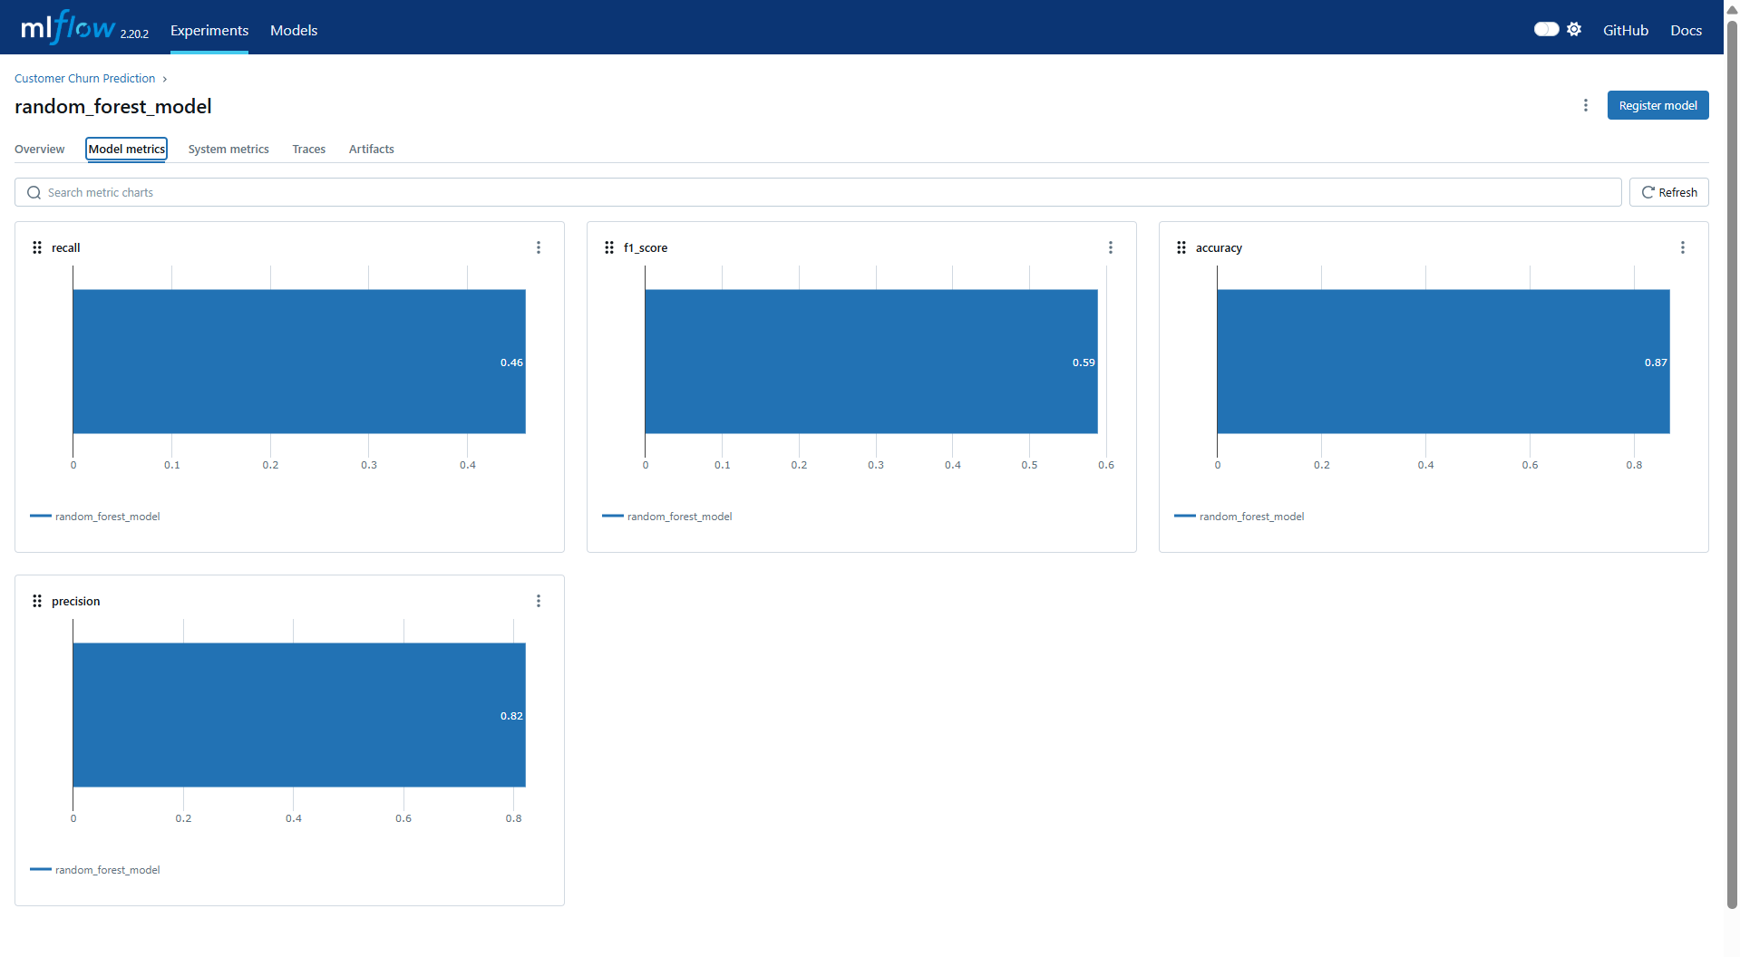

We can see we have latest version for logistic model on version 3 and for random forest on version 2
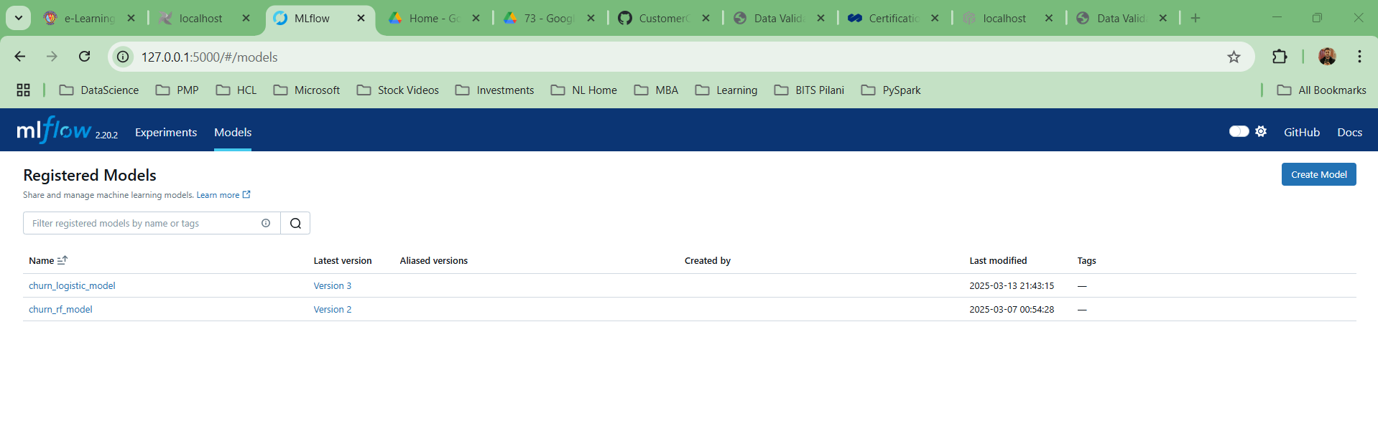
Versions of logistic model
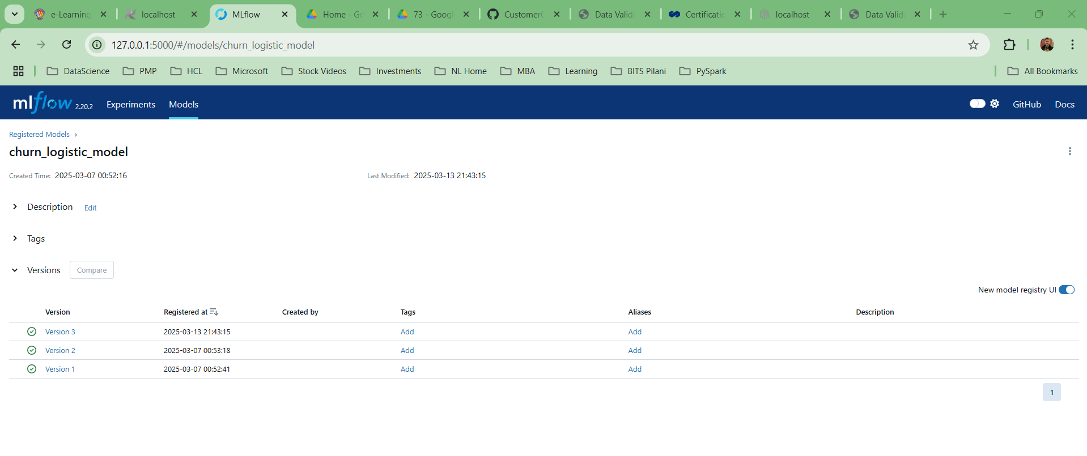
While comparing version 2 and version 3 we can see there is a slight marginal increase in the model performance metrics for logistic model
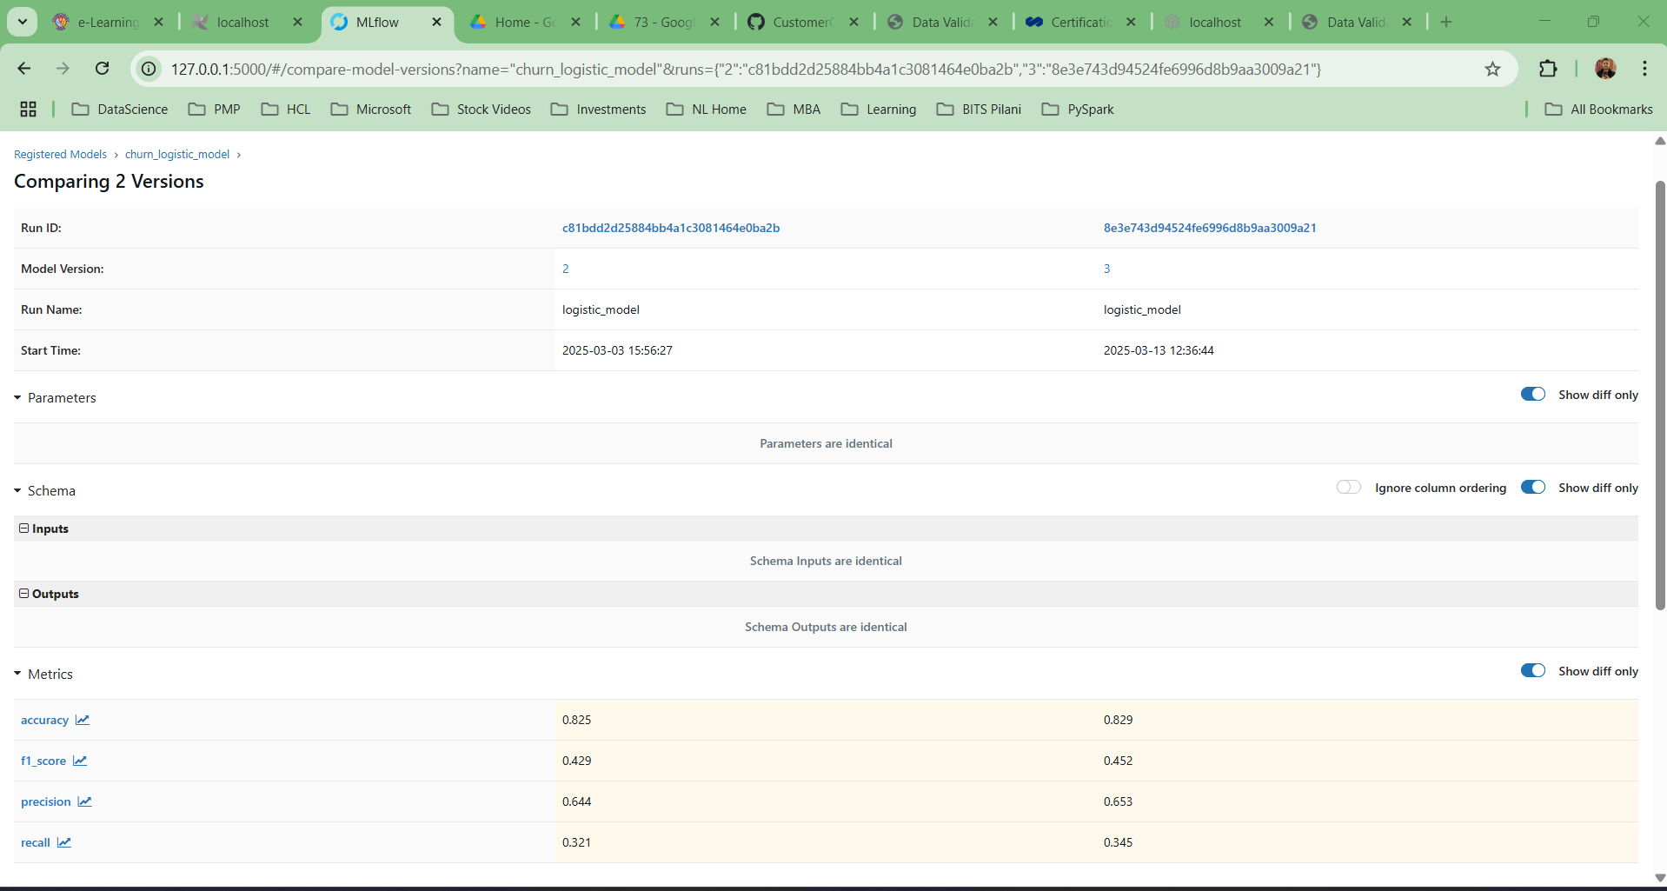

Versions of random forest model
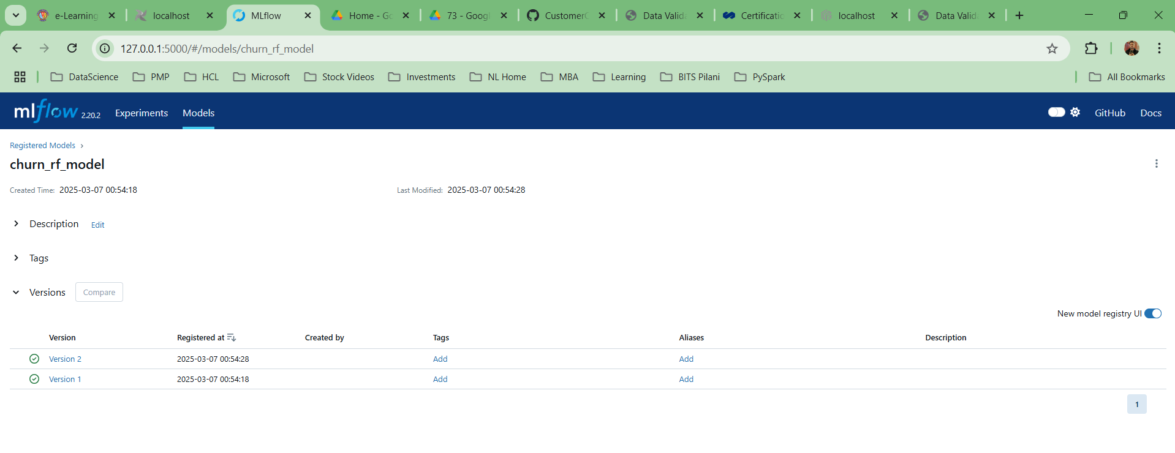

While comparing version 2 and version 3 we can see there is a slight marginal increase in the model performance metrics for random forest model

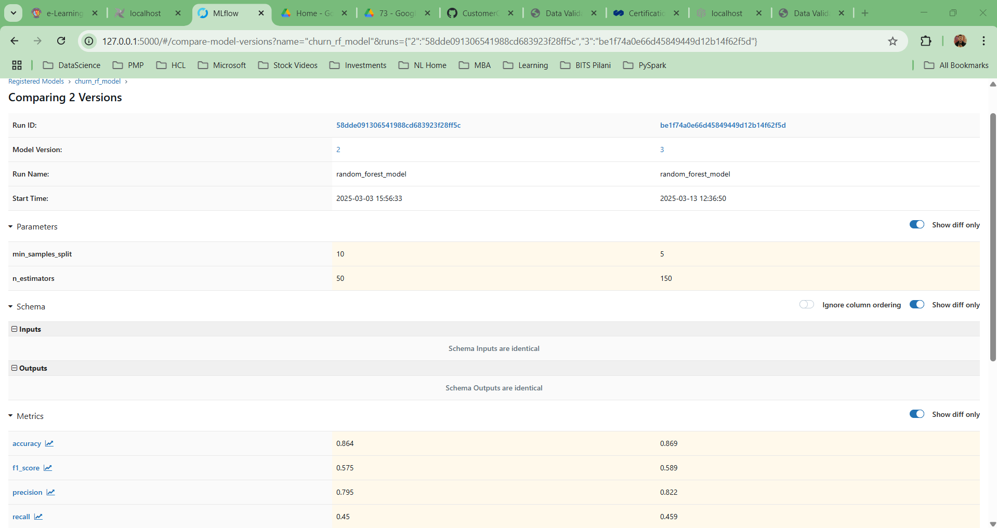

Performance Metrics overview for all models
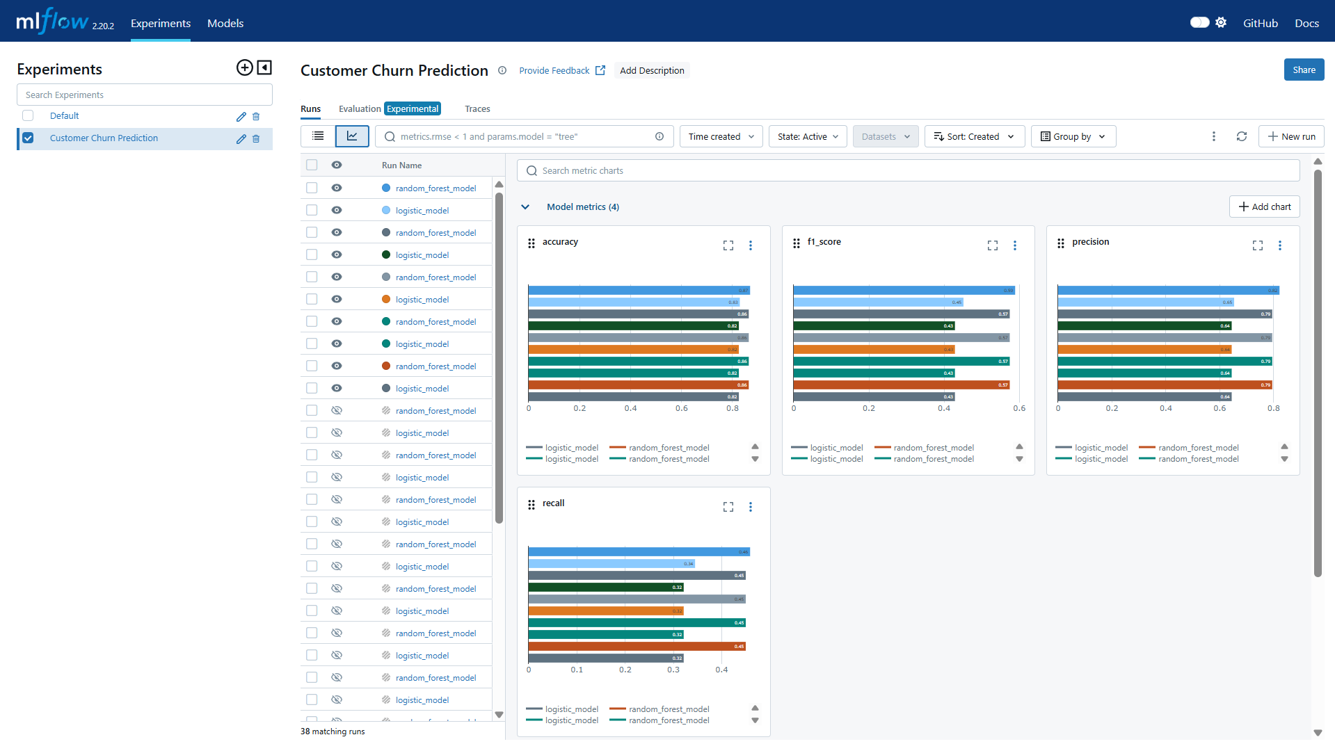

Different versions of model (.pkl) file stored in git repo
